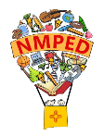

New Mexico Online Interim and Summative Assessments
**iTester Portal Updates**

Greetings,

This is to let you know that we plan to release a few updates for the following Operating Systems effective Friday, November 21, 2025. Below are more details for each of these updates along with a few additional updates.
- iPad OS
- Chrome OS Carrier Extension

iTester iPadOS Update
We are releasing an update to the iTester iPadOS app on November 21 that includes bug fixes and performance improvements.
While updating is not required for iMSSA MOY and there will no impact on student testing, we recommend updating all iPads intended for testing to the latest version by following the steps below:

Steps to Update the iTester App on iPadOS
- If Automatic Updates Are Enabled:
  - No action is needed. The iTester app will update automatically when a new version is available.
- If Automatic Updates Are NOT Enabled, then do the following:
- Open the App Store on your iPad.
- Tap your Apple ID icon or profile picture in the top-right corner.
- Scroll down to view pending updates.
- Find the iTester app in the list.
- Tap Update next to the iTester app.

Chrome OS Update
We plan to release an update to the iTester ChromeOS Carrier Extension on November 21, along with iPad updates.

All Chromebook devices will automatically receive this update once it is deployed. No action will be required on the part of the school or district.

User Upload Data Definitions Added
We have added a User Upload Data Definitions File to the portal, under the Users tab when you click to Import Users.
This will help Test Administrators with uploading users, having a data file definition alongside the import template. This will help users understand the expected data structure and formatting requirements.
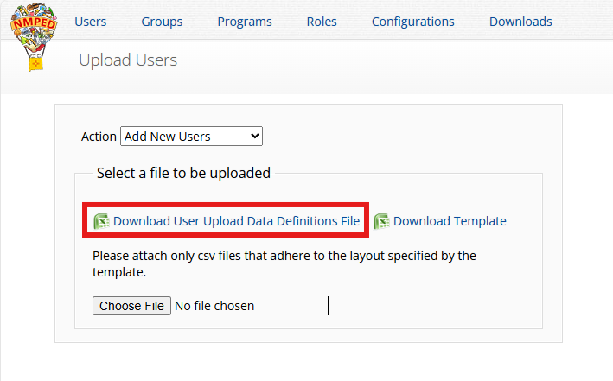

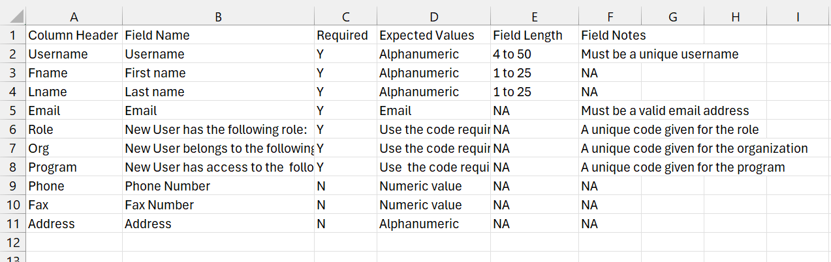

New User Email Notification Update
When we consolidated to a single email sent to new users to login to their portal accounts, the Username was excluded in the email body. We have already made this change on the backend and will now go to Production. This will clear up Username confusion with new users logging into the portal. This update will go live on November 25, 2025.
See below email sample
Hello Fname Lname,
We are pleased to inform you that your account for the New Mexico Public Education Department Assessments Portal has been successfully created. Your username is [username]. To get started, please click the link below to access the site and set your password.
Link to account update
Please contact Cognia Support at nmtechsupport@cognia.org or (877) 676-6722 if you have any questions.
Thank you,
Cognia Support

Enhanced Test Session Metrics to Display Time Spent with Seconds for Improved Precision Update
When Time under one-minute shows seconds, time under an hour shows minutes and seconds, and time over an hour shows hours, minutes, and seconds.

Added Export Accommodations Permission
To enable accommodation exports without requiring upload permissions.
- Users with this permission can export accommodations independently of the Upload Accommodations configuration and Edit Student permission.
- All user roles except Test Administrator, Reports Access Only, and IT Coordinator have this permission currently on UAT.
For any questions, please contact the New Mexico Help Desk by phone at 877-676-6722, by email at NMTechSupport@cognia.org, or by using the Live Chat Link available on the New Mexico Help & Support Help & Support Site.

- Standard hours: Monday–Friday, from 7:00 a.m.–3:00 p.m. (MT)
- 9:00 a.m.–5:00 p.m. (ET)
- 8:00 a.m.–4:00 p.m. (CT)
- 6:00 a.m.–2:00 p.m. (PT)

